**Week 1 – MONGO Database(No SQL)**

**Name: Divyanshu Sharma**

**SRN: PES1UG20CS806**

| **Problem Statement** | Use MongoDB and create a sample database and perform the following operations on it  1. Create documents with varying fields.  2. Use the insert and save commands.  3. Drop an existing database and a collection and use remove() to delete documents.  4. Update an existing document in a collection. (update() )  5. Use find () and findOne () for querying the database. |
| --- | --- |

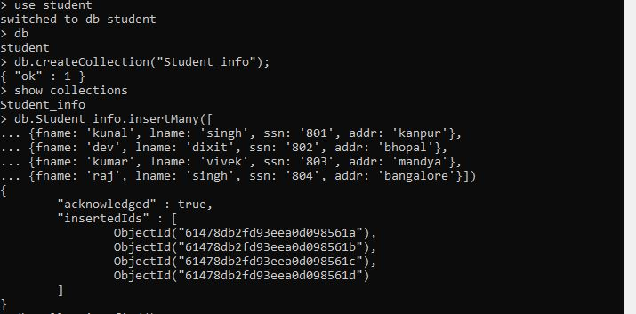**1.Create Operations:**

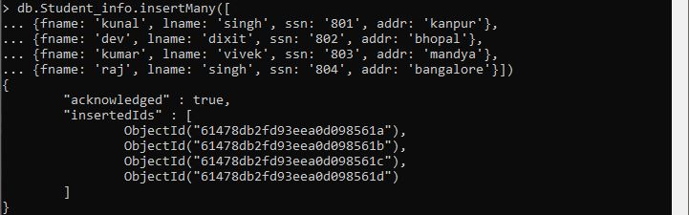**2. Insert Command:**

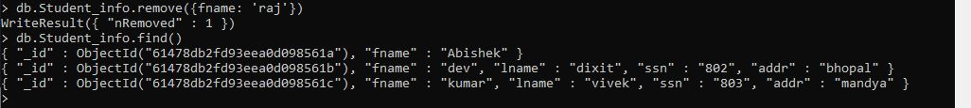**3. Remove() to delete documents And Drop Command:**

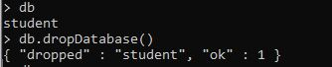**DROP Command:**

**4. Update Command:**

After update:

**5. Use find () Command:**